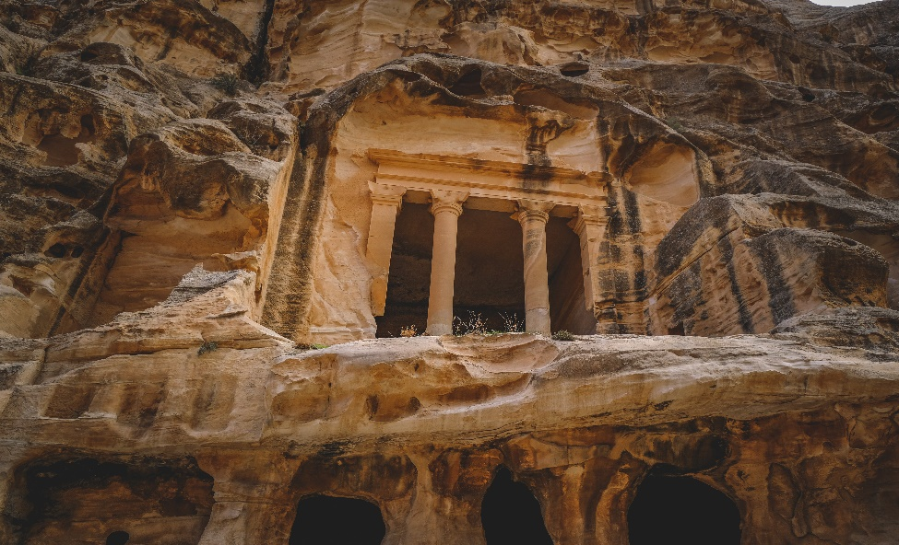

History of Petra

Petra, often referred to as the "Rose City," is an ancient archaeological site located in southern Jordan. It is renowned for its remarkable rock-cut architecture and its role as the capital of the Nabatean Kingdom. Here's an overview of the history of Petra:

**1. Establishment (4th Century BC):** Petra's history can be traced back to the 4th century BC when it was established as the capital city of the Nabateans, an ancient Arab civilization known for their trade and water management skills. The city's strategic location along the Silk Road trade routes contributed to its prosperity.

**2. Trade Hub:** Petra flourished as a major trade hub, serving as a crossroads for the caravan trade routes that connected the Arabian Peninsula, Egypt, and the Mediterranean. It was particularly famous for its role in the spice trade.

**3. Unique Architecture:** What makes Petra extraordinary is its rock-cut architecture. The city is filled with structures carved directly into the rose-colored sandstone cliffs, creating a stunning blend of natural beauty and human craftsmanship. The most famous of these structures is the Treasury (Al-Khazneh), which is intricately carved and has been featured in movies like "Indiana Jones and the Last Crusade."

**4. Roman Annexation (1st Century BC**): In 106 AD, the Romans annexed Petra and it became part of the Roman Empire's province of Arabia. Petra continued to prosper under Roman rule and underwent significant architectural developments.

**5. Decline:** Petra's importance gradually declined as trade routes shifted and the Roman Empire shifted its focus elsewhere. By the 7th century AD, the city was largely abandoned, and it fell into obscurity.

**6. Rediscovery (19th Century):** Petra remained largely forgotten by the Western world until Swiss explorer Johann Ludwig Burckhardt rediscovered it in 1812. His accounts of the hidden city generated considerable interest among European explorers and scholars.

**7. UNESCO World Heritage Site (1985):** In recognition of its cultural significance and architectural beauty, Petra was designated as a UNESCO World Heritage Site in 1985. It is also one of the New Seven Wonders of the World.

**8. Modern Tourism:** Today, Petra is one of Jordan's most visited tourist destinations. It has been featured in numerous films, documentaries, and travel guides. The site has seen extensive preservation and restoration efforts to protect its fragile structures and ensure its continued accessibility to visitors.

Petra's rich history, stunning architecture, and unique location make it a testament to the ingenuity of ancient civilizations and a must-visit destination for travelers interested in history and archaeology